CANDIDATES NAME: …………………………………………………………….
INDEX NUMBER
SIGNATURE: …………………………………

553/1
BIOLOGY
PAPER 1
JUNE/JULY
2 HOURS 30 MINUTES

MOCK EXAMINATIONS SET 1 2019
Uganda Certificate of Education
BIOLOGY
PAPER 1
(Theory)
2 HOURS 30 MINUTES

INSTRUCTIONS TO CANDIDATES:

- This paper consists of three sections A, B and C.
- Answer all questions in section A, and B, plus two questions in section C.
- Write the answers to section A in the boxes provided and answers to section C on answer sheets provided.
- Any additional question(s) answered will not be marked.

The figure below shows a diagram of a cockroach, Periplaneta americana. Study it carefully and answer questions 1 to 5.
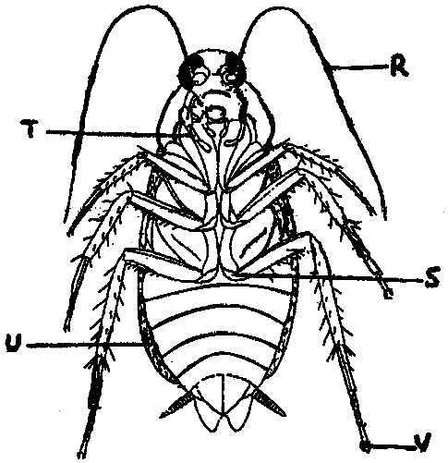
1. The view from which the animal is being observed is:
A. Dorsal. B. Ventral. C. Lateral. D. Hind.

2. Which of the following is not a function of the structure marked R?
A. Feeling. B. Smelling.
C. Detection of sound waves. D. Defense tool.

3. From the above diagram, it can be observed that the sex of the animal is:
A. Male. B. Female.
C. Hermaphrodite. D. Can’t be seen.

4. The reason for the sex suggested in Qn. 3 above is:
A. Possession of the style. C. Possession of the anal cerci.
B. Possession of podical plate. D. Existence of a big head.

5. The animal can move on a flat ceiling when it is upside down without falling because of possession of structure:
A. S B. T C. U D. V

The diagram below shows a human sperm cell. Answer the questions that follow:
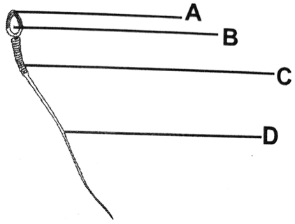

6. Which of the following parts contains the chromosomes?
A. D B. B C. A D. C

7. What is the importance of part labelled C?
A. Contains the male gamete
B. Contains mitochondria which generate energy
C. Propels the sperm during movement
D. Stores food for the sperm

8. Which part of the sperm makes it easy to move?
A. D B. C C. B D. A

9. What causes the corpus luteum to degenerate?
A. Drop of luteinizing hormone
B. Increase in progesterone
C. Increase in oestrogen
D. Production of FSH

10. Which of the following is not a characteristic of DNA?
A. It is able to replicate during mitosis and meiosis
B. It continues unchanged from generation to generation
C. It is made of ribonucleic acid
D. It acts as a code designing the amino acid

11. Which of the blood groups would not be produced by a man of blood group AB married to a woman of blood group AO?
A. AO B. BO C. AB D. OO

12. An organism is said to have adapted to its environment when:
A. It has characteristics which enables it to live in that environment
B. It is highly specialised
C. It can change the environment to suit its life style
D. It can live in different habitats at the same time

13. What brings about resemblance of offsprings to their parents?
A. Reproducing cells from the same cell
B. Playing magic on pregnant women
C. Inheritance of combination of factors
D. Inheritance of characters

14. Which one of the following is used for transmission of information?
A. Guard cell B. Nerve cell
C. Parenchyma cell D. Muscle cell

The diagram below shows the structure of a villus in the ileum.
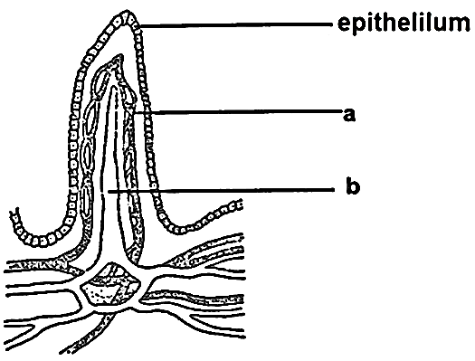
15. Which of the following food substances are carried in the part labeled (b) in the diagram?
A. Fatty acids and glycerol B. Glucose
C. Vitamins D. Mineral salts

16. What name is given to part labeled (b)?
A. Capillaries B. Lacteal
C. Lymph node D. Micro villi

17. What role is played by part labeled (a)?
A. Storage of glucose
B. Transportation of absorbed nutrients
C. Transporting fats and mineral salts
D. Protecting inner lining of villi

18. In which part of the kidney nephron does re – absorption of glucose occur?
A. Distal convulated tubule B. Proximal convulated tubule
C. Descending loop of Henle D. Ascending loop of Henle

19. The main reason for including legumes in a crop rotation is to:
A. Improve the level of nitrogen in the soil
B. Maintain useful bacteria in the soil
C. Prevent soil erosion
D. Improve farming methods

The figure below shows a vertebra bone. Use it to answer questions 20 and 21.
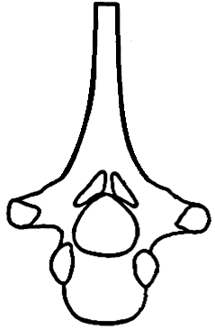
20. Name the type of vertebra shown in the figure.
A. Atlas C. Lumbar
B. Thoracic D. Axis

21. In which part of the body is the vertebra above found?
A. Neck C. Abdominal
B. Chest D. Tail

22. Production of many pollen grains is an adaptation for:
A. cross pollination C. wind pollination
B. insect pollination D. self-pollination

23. In the colonization of a bare rock, the next most likely group of plants after the lichens are the:
A. grass C. Shrubs
B. mosses D. Trees

The graph below shows the number of individuals varying with a given characteristic in a population.
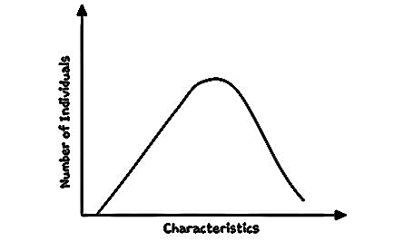

24. Which one of the following characteristics would produce the graph in the figure above?
A. Height B. Sex type
C. Blood group D. Albinism

25. The part of a Bryophyllum plant leaf for vegetative propagation is the;
A. Lamina B. Notch
C. Bud D. Apex

26. Crossing over occurs during;
A. Prophase of mitosis B. Prophase of meiosis
C. Metaphase of mitosis D. Metaphase of meiosis

27. Which one of the following vertebrae has demifacets?
A. Thoracic vertebra B. Lumbar vertebra
C. Cervical vertebra D. Atlas

28. The excretory structures for an insect are;
A. Trachea B. Malpighian tubules
C. Tracheoles D. Spiracles

29. Which of the following parts are for hearing and body posture?
A. Cochlea and cerebellum
B. Cochlea and cerebrum
C. Eustachian tube and cerebrum
D. Eustachian tube and cerebellum

30. The non-functional human appendix is an example of;
A. Homologous structures B. Analogous structures
C. Vestigial structures D. None of the above

SECTION B: (40 MARKS)

31. A person seated in a dark room is asked to cover one of his eyes. In an experiment a boy was then made to look at a bright lamp placed just in front of him. The lamp was gradually moved away from the boy and the diameter of both the eye lens and the pupil was determined and recorded
in the table below.

Distance moved by the lamp in cm | Diameter in mm
Distance moved by the lamp in cm | Eye lens | Pupil
20 | 9.70 | 0.30
80 | 5.90 | 2.65
140 | 4.70 | 5.30
200 | 2.50 | 6.80
260 | 2.00 | 7.50

a) Plot a graph to represent the information in the table above.
(06 marks)
b) State the relationship between distance moved by the lamp and diameter of:
(i) Eye lens (01 mark)
………………………………………………………………………………………………...
………………………………………………………………………………………………...
(ii) Pupil (01 mark)
………………………………………………………………………………………………...
………………………………………………………………………………………………...
c) From your graph, determine the diameter of both the eye lens and pupil when a lamp is placed 110cm from the boy.
(i) Pupil (01 mark)
………………………………………………………………………………………………...
………………………………………………………………………………………………...
(ii) Eye lens (01 mark)
………………………………………………………………………………………………...
………………………………………………………………………………………………...
d) Explain how and why the pupil adjusted from the diameter of 0.30mm to 5.30mm (05mks)
………………………………………………………………………………………………...
………………………………………………………………………………………………...
………………………………………………………………………………………………...
………………………………………………………………………………………………...
………………………………………………………………………………………………...

e) Describe how an object in contact with the bulb placed at a distance of 260cm accommodated by the eye. (03mks)
………………………………………………………………………………………………...
………………………………………………………………………………………………...
………………………………………………………………………………………………...
………………………………………………………………………………………………...
………………………………………………………………………………………………...
g) What is the adaptive significance of the diameter of the pupil when the lamp was only 20cm from the boy? (02mks)
………………………………………………………………………………………………...
………………………………………………………………………………………………...
………………………………………………………………………………………………...
………………………………………………………………………………………………...

32. While moving around the school compound students collected the following data and recorded it in the table below.

Organism | Number of organisms
Lizards | 50
Grass | 500,000
Snakes | 10
Grasshoppers | 1,000
Hawks | 4

a) From the data obtained, state the biological pyramid a student would use to represent this information. (01mk)
………………………………………………………………………………………………...
………………………………………………………………………………………………...
b) Draw the biological pyramid identified in (a) above to represent the information obtained by the student (05mks)

c) Which organisms are expected to have the;
(i) Largest biomass (½ mks)
………………………………………………………………………………………………...
………………………………………………………………………………………………...

(ii) Least amount of energy (½ mks)
………………………………………………………………………………………………...
………………………………………………………………………………………………...
d) (i) State the method used by the student to determine the number of Hawks (01mk)
………………………………………………………………………………………………...
………………………………………………………………………………………………...
(ii) What are the advantages of using such a method in estimation of population of organisms? (02mks)
………………………………………………………………………………………………...
………………………………………………………………………………………………...

33. The figure below shows structures of plants drawn from vertical sections. Study them carefully and answer the questions that follow.
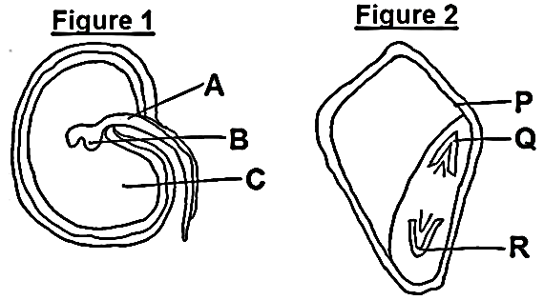
a) Name the labelled parts on the figure. (03mks)
A P
B Q
C R

b) (i) Suggest the subclass (division) of the plants from which they were obtained. (01mk)
Sub class of figure 1
………………………………………………………………………………………………...
………………………………………………………………………………………………...
Sub class of figure 2
………………………………………………………………………………………………...
………………………………………………………………………………………………...
(ii) Basing on the answer in b (i), give two differences observed in the plants that germinate, grow and develop from figure 1 and figure 2

Figure 1 | Figure 2

c) Briefly describe how germination occurs in figure 1 under favourable conditions. (04mks)
………………………………………………………………………………………………...
………………………………………………………………………………………………...
………………………………………………………………………………………………...
………………………………………………………………………………………………...
………………………………………………………………………………………………...

SECTION C: (30 MARKS)
Attempt only two questions from this section.

34. a) Define the term Osmoregulation (01mk)
b) Describe the mechanism of Osmoregulation in the human body under the following conditions
i) High osmotic pressure (07mks)
(ii) Low osmotic pressure (07mks)

35. a) Using relevant examples, describe how asexual reproduction occurs naturally in different organisms. (10mks)
b) What advantages are associated with asexual reproduction as opposed to sexual method? (05mks)

36. a) What is meant by the term pollution? (02mks)
b) How does man contribute to environmental pollution (07mks)
c) State the dangers of pollution to the environment (06mks)

37. a) Describe an experiment how you can demonstrate the presence of bacteria in a fresh soil sample. (12mks)
b) State three ways in which bacteria are involved in making nitrogen available in the soil for green plants. (03mks)
END

